Containerization and Devops lab Experiment -2
Name: Sourabh Saini
Roll no: R2142230968
Sap-ID: 500124739


School of Computer Science,
University of Petroleum and Energy Studies, Dehradun

EXPERIMENT – 2

Docker Installation, Configuration, and Running Ima ges

Aim
To install and configure Docker, pull Docker images, run containers and manage the container lifecycle using Docker commands.

Objectives
- To pull Docker images from Docker Hub
- To run containers with port mapping
- To verify running containers
- To manage container lifecycle (start, stop, remove)

Theory
Docker is an open-source containerization platform that allows applications to be packaged along with their dependencies into lightweight, portable containers. Containers run on a shared operating system kernel, making them faster and more resource-efficient than traditional virtual machines.

A Docker Image is a read-only template used to create containers. A Docker Container is a running instance of a Docker image.
Docker uses a client–server architecture, where the Docker client communicates with the Docker daemon to build, run, and manage containers.

Software Requirements
- Windows OS
- Docker Desktop with WSL integration
- Ubuntu (WSL distribution)

Procedure / Steps to Perform the Experiment

Step 1: Pull Docker Image
The Nginx image is pulled from Docker Hub using the following command:
docker pull nginx

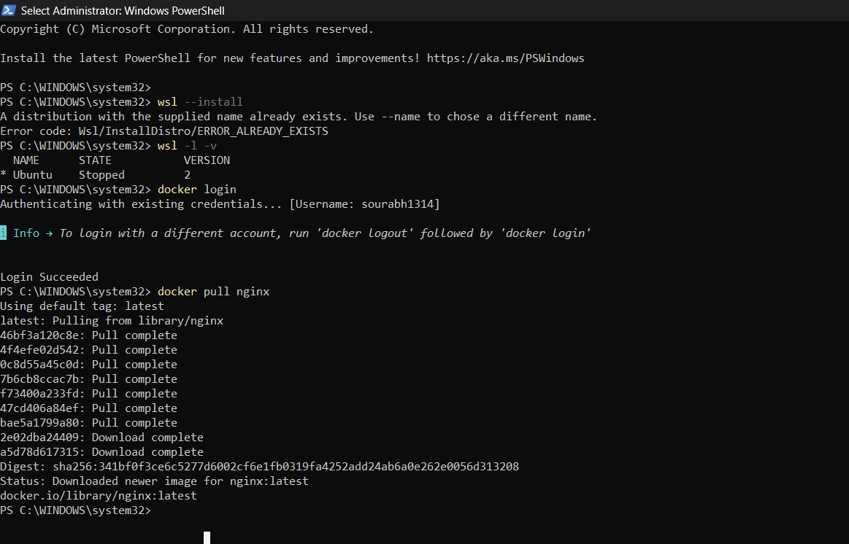

This command downloads the latest official Nginx image to the local system.

Step 2: Run Container with Port Mapping
Run the Nginx container in detached mode with port mapping:
docker run -d -p 8080:80 nginx
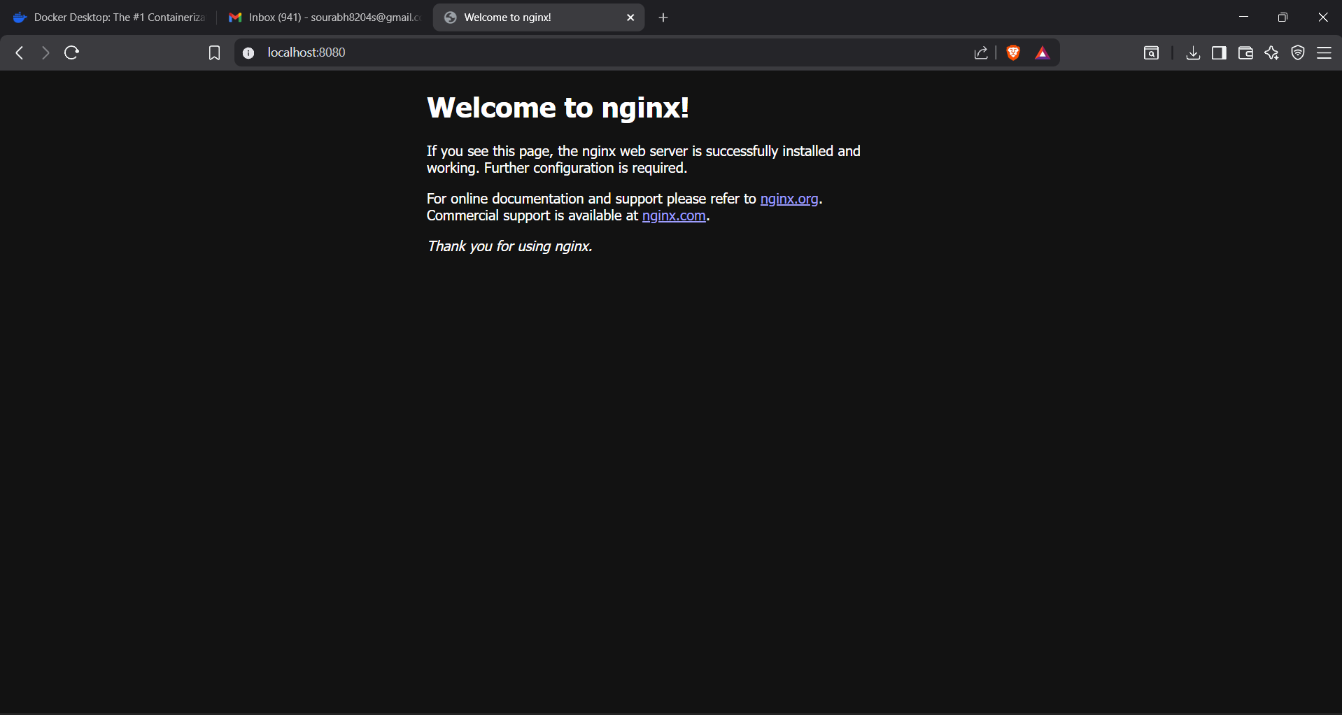

Explanation:
- -d → Runs container in background
- -p 8080:80 → Maps host port 8080 to container port 80
- nginx → Docker image name

Step 3: Verify Running Containers
To check running containers, execute:
docker ps

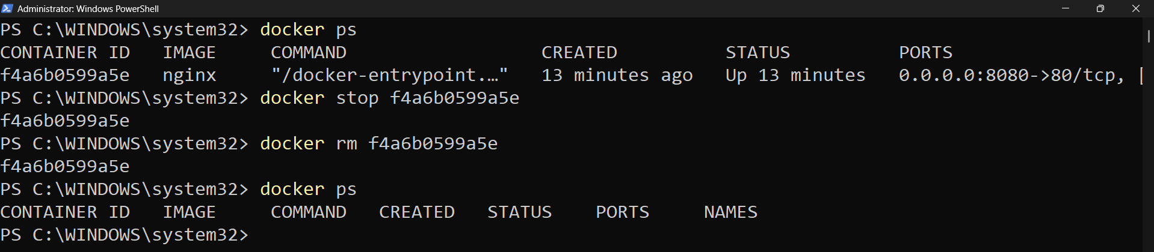

This displays the container ID, image name, status, and port mapping.
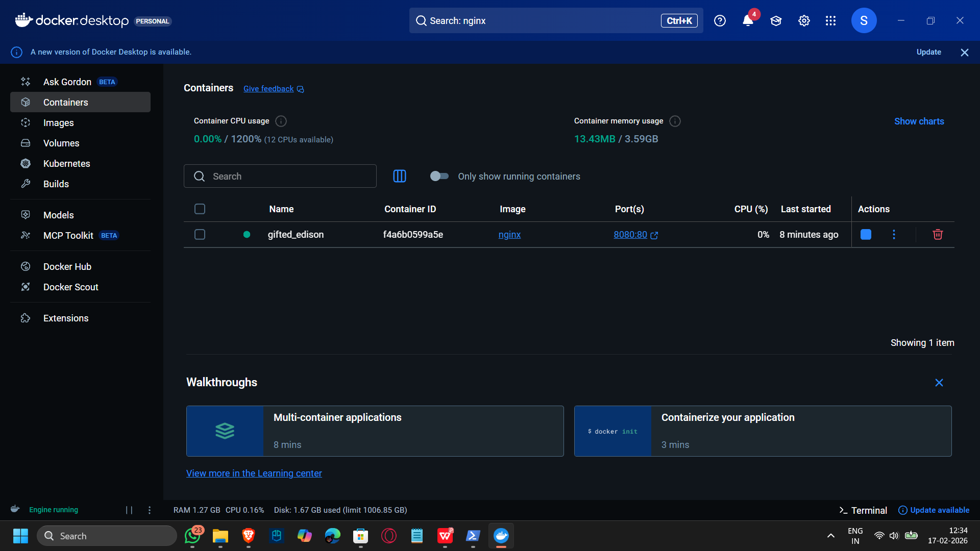

Step 4: Stop and Remove Container
To stop the running container:
docker stop <container_id>


To remove the container:
docker rm <container_id>



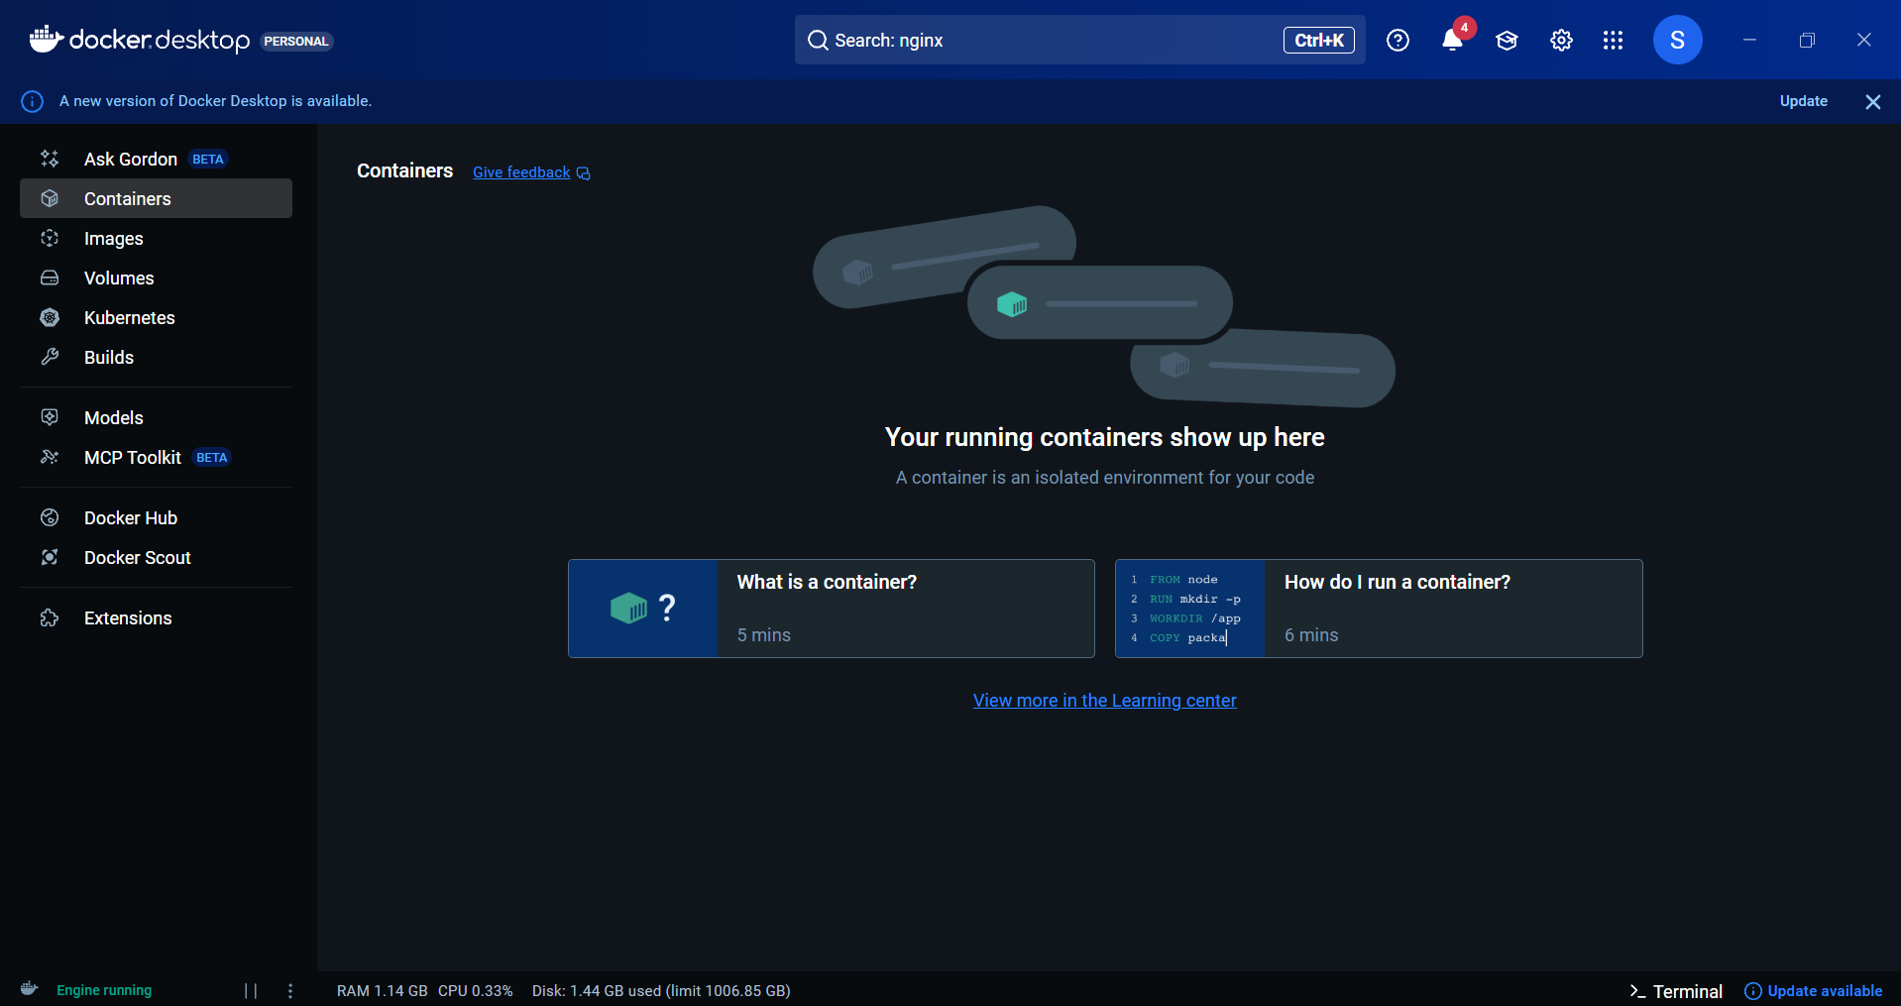

Step 5: Remove Docker Image To remove the downloaded image:
docker rmi nginx

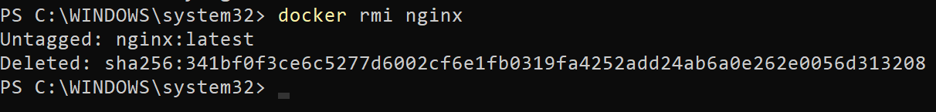

This frees disk space by deleting the unused image.

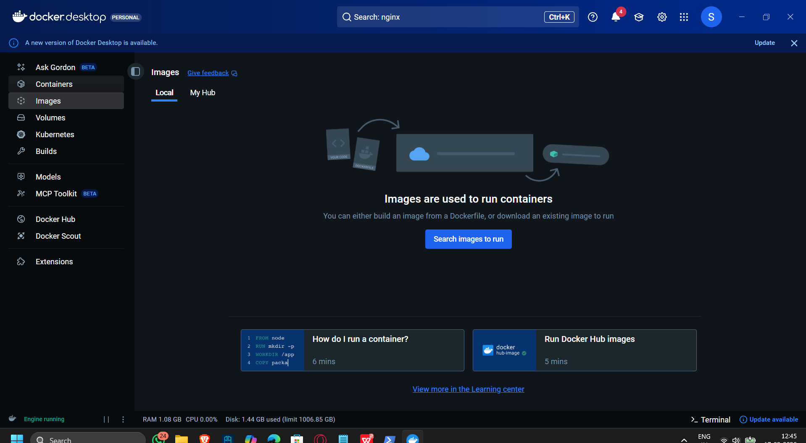

Result
Docker images were successfully pulled, containers were executed, and container lifecycle management commands were performed successfully.
Exp 2

Conclusion
This experiment demonstrated the use of Docker for application deployment using containers. Docker provides a lightweight, efficient, and portable environ ment for running applications, making it suitable for modern DevOps and cloud- native applications.

Viva-Voce Questions (Very Important)
- What is a Docker image?
- What is a Docker container?
- Difference between docker run and docker start?
- Purpose of port mapping in Docker?
- Why are containers lightweight compared to VMs?

Overall Conclusion
This lab demonstrated virtualization using Vagrant + VirtualBox and containerization using Docker, highlighting clear performance and resource efficiency differences. Containers are better suited for rapid deployment and microservices, while VMs provide stronger isolation.

